**A Research Paper on**

**DIGITAL LOGICS**



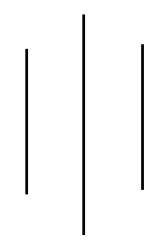

**Submitted By:**

Sanam Tamang

Symbol No: 76214020

T.U Regd No: 9-2-214—2019

**Submitted To:**

Mr. Biraj Subedi

Lecturer

Sukuna Multiple Campus

Sundarharaincha, Morang

In partial fulfillment of the requirement for the course BICTE $2^{th}$ semester

August 24, 2021